Project Design Phase-I
Problem – Solution Fit Template

Date | 24 October 2026
Team ID | [Enter Team ID]
Project Name | Electric Vehicle Market Performance & Insights
Maximum Marks | 2 Marks

Problem – Solution Fit Template:
The Problem-Solution Fit simply means that you have found a problem with your customer and that the solution you have realized for it actually solves the customer’s problem. It helps entrepreneurs, marketers and corporate innovators identify behavioral patterns and recognize what would work and why
Purpose:
- Solve complex problems in a way that fits the state of your customers.
- Succeed faster and increase your solution adoption by tapping into existing mediums and channels of behavior.
- Sharpen your communication and marketing strategy with the right triggers and messaging.
- Increase touch-points with your company by finding the right problem-behavior fit and building trust by solving frequent annoyances, or urgent or costly problems.
- Understand the existing situation in order to improve it for your target group.

Template:
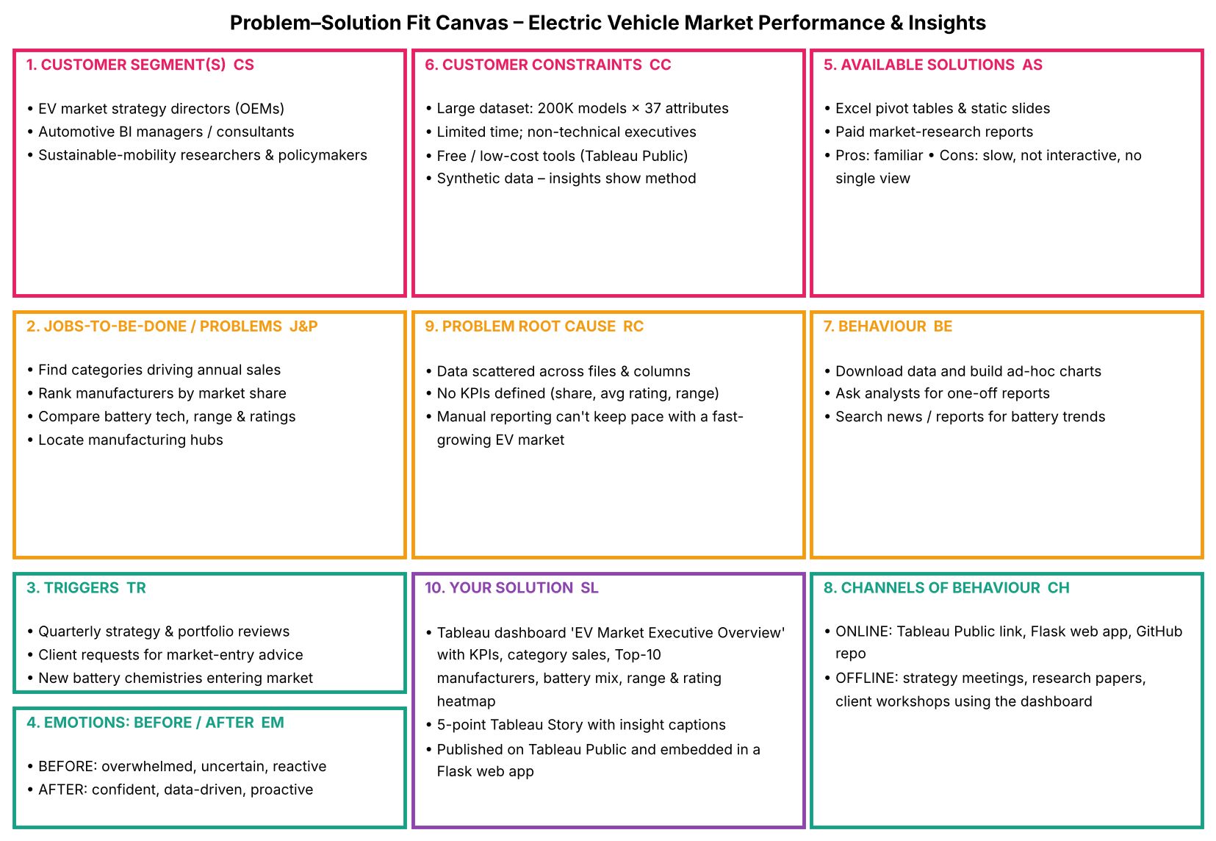

Summary of fit: Strategy, BI and research users struggle to turn a 200,000-model EV dataset into decisions. The root cause is scattered, un-aggregated data with no defined KPIs. The Tableau 'EV Market Executive Overview' dashboard and 5-point Story fit their existing behaviour (reviewing reports before quarterly decisions) by delivering the same answers – category sales, market share, battery mix, range, geography and ratings – in one interactive, shareable view.
References:
- https://www.ideahackers.network/problem-solution-fit-canvas/
- https://medium.com/@epicantus/problem-solution-fit-canvas-aa3dd59cb4fe

